Data Analyst Nanodegree

Explore Weather Trends

By Shubhankar Ghosh

Steps taken to perform the analysis:-

1. Extracted data from the database

The queries that follow are:-

|  |
| --- |
| SQL Queries |
| select * from city_list where country='India'; |
| select * from city_data where country='India' and city='Pune'; |
| select * from global_data; |

The following steps that I performed were using python and Jupyter notebook. Hence I first imported the required libraries using the commands:-

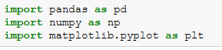

1. Reading the data from the csv file that we download after the sql queries run successfully.

This can be done using 2 methods-either open it directly in your folder or do it using the pandas command:-



1. Then I calculated the moving average of the weather temperatures. It can be done using two methods- either using excel sheet formula:-

Example- AVERAGE(B2:B10) or using pandas commands:-

I used the pandas command-



1. After calculating the moving averages I plotted the line chart using the plot function of matplotlib :-

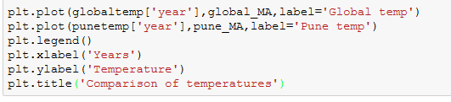

1. As per the above matplotlib commands, we get the following line chart:-

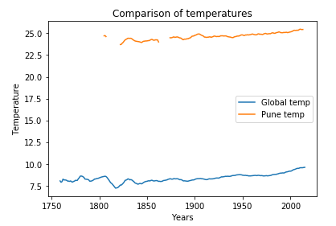

1. What did I analyze from the above graph?

* As per the graph, it is clear that Pune is hotter than other cities around the world. The difference has been consistent over time.
* Over the last 10 years the temperature of Pune has soared even higher which is not a good sign.
* The moving average temperature of other cities around the globe from the year 2004-2013 is 9.556 **°**C, on the other hand the moving average temperature for Pune from the year 2004-2013 is 25.446 **°**C. This also clearly shows how much hot it has been in Pune over the years.
* The graph clearly shows that as we progress into the years, the graph of temperatures is showing an inclination for both Pune as well as other cities globally which means the global warming effect is still very predominant everywhere in the future years to come unless we all try and make our cities cooler maybe by planting more trees.